# Template answers.
# It's available to make a link to attached file.
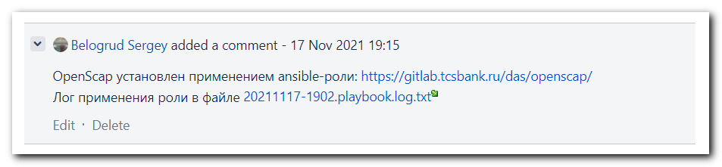
OpenScap установлен применением ansible-роли: https://gitlab.tcsbank.ru/das/openscap/
Лог применения роли в файле 20211117-1902.playbook.log.txt

# Here are other frequently asked roles, as well.
#
Применены ansible-роли:
https://gitlab.tcsbank.ru/das/clamav/
https://gitlab.tcsbank.ru/das/openscap/
https://gitlab.tcsbank.ru/das/auditd/ (v2.0.14)

https://vm-gitlab01.tcsbank.ru/infra-compute/clamav/clamav_signatures

На следующие серверы из списка не удаётся залогиниться по ssh под учётными записями unix-admins. Пожалуйста обратитесь к бизнес-пользователям-владельцам этих хостов, чтобы они самостоятельно произвели требующиеся настройки или создали сервисные учётные записи для unix-admins.

ds-pr-acq-posapi03p
ds-pr-eacq-apigw01p
ds-pr-eacq-paymentform01p
ds-sblapp13p
m1-pr-eacq-mapi-pf02p

*. Jira. Задача "Установка Clamav на сервера из скоупа ЦБ" (https://jira.tcsbank.ru/browse/IN-1730) [Petrova Yulia].
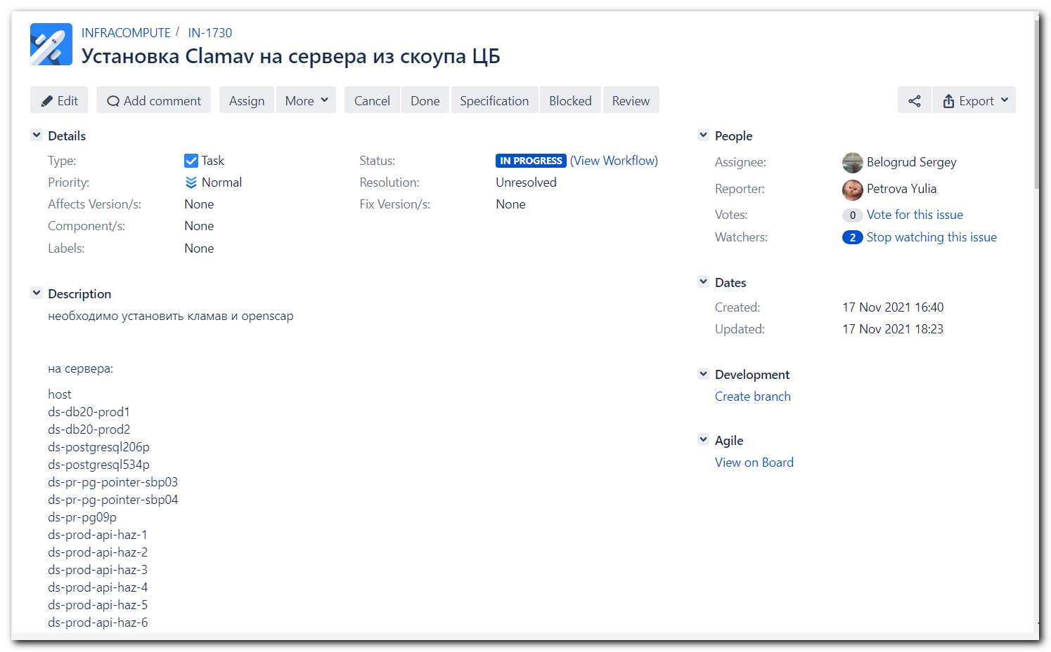

https://tinkoff.slack.com/archives/GHN18GB2M/p1637156512002300
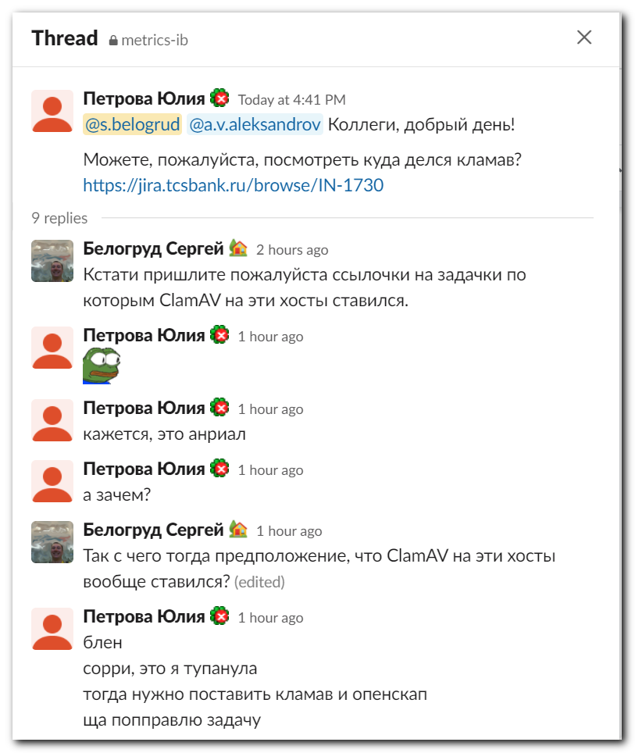
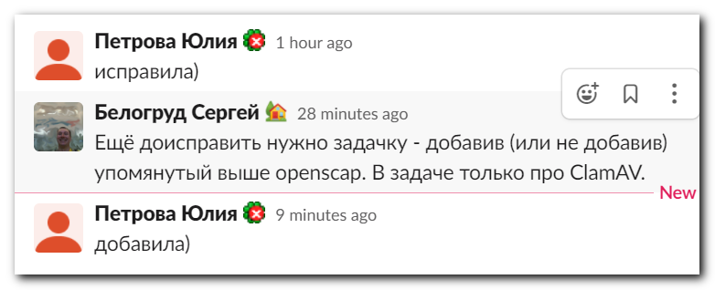

Nov 17, 2021 I tested ClamAV version on the list of hosts. And availability of the hosts.
On some hosts didn't exist login unix-ansible. I created this account on them. Some hosts were not accessable at all for differ accounts.

# s_s.belogrud
[support@nb2339]# export ANSIBLE_CONFIG=ansible.cfg ; logfile="$(date +%Y%m%d-%H%M).playbook.log.txt" ; ansible cmd_command -i list_of_hosts -m shell -a '(which yum 1>/dev/nul 2>&1 && yum list installed clamav ; which apt 1>/dev/nul 2>&1 && apt list --installed clamav 2>/dev/nul) | grep -ie clamav ; echo' --become --extra-vars "ansible_user=s_s.belogrud ansible_password=$(pass common/linux-freeipa) ansible_sudo_pass=$(pass common/linux-freeipa) ansible_ssh_common_args='-oStrictHostKeyChecking=no -oPubkeyAuthentication=no -oUserKnownHostsFile=/dev/null'" | tee -a ./output/${logfile}

# svc_unix_ansible
[support@nb2339]# export ANSIBLE_CONFIG=ansible.cfg ; logfile="$(date +%Y%m%d-%H%M).playbook.log.txt" ; ansible cmd_command -i list_of_hosts -m shell -a '(which yum 1>/dev/nul 2>&1 && yum list installed clamav ; which apt 1>/dev/nul 2>&1 && apt list --installed clamav 2>/dev/nul) | grep -ie clamav ; echo' --become --extra-vars "ansible_user=svc_unix_ansible ansible_password=$(pass common/linux-svc_unix_ansible) ansible_sudo_pass=$(pass common/linux-svc_unix_ansible) ansible_ssh_common_args='-oStrictHostKeyChecking=no -oPubkeyAuthentication=no -oUserKnownHostsFile=/dev/null'" | tee -a ./output/${logfile}

# unix-ansible
[support@nb2339]# export ANSIBLE_CONFIG=ansible.cfg ; logfile="$(date +%Y%m%d-%H%M).playbook.log.txt" ; ansible cmd_command -i list_of_hosts -m shell -a '(which yum 1>/dev/nul 2>&1 && yum list installed clamav ; which apt 1>/dev/nul 2>&1 && apt list --installed clamav 2>/dev/nul) | grep -ie clamav ; echo' --become --extra-vars "ansible_user=unix-ansible ansible_password=$(pass common/linux-unix-ansible) ansible_sudo_pass=$(pass common/linux-unix-ansible) ansible_ssh_common_args='-oStrictHostKeyChecking=no -oPubkeyAuthentication=no -oUserKnownHostsFile=/dev/null'" | tee -a ./output/${logfile}

# bsv
[support@nb2339]# export ANSIBLE_CONFIG=ansible.cfg ; logfile="$(date +%Y%m%d-%H%M).playbook.log.txt" ; ansible cmd_command -i list_of_hosts -m shell -a '(which yum 1>/dev/nul 2>&1 && yum list installed clamav ; which apt 1>/dev/nul 2>&1 && apt list --installed clamav 2>/dev/nul) | grep -ie clamav ; echo' --become --extra-vars "ansible_user=bsv ansible_password=$(pass common/linux-bsv) ansible_sudo_pass=$(pass common/linux-bsv) ansible_ssh_common_args='-oStrictHostKeyChecking=no -oPubkeyAuthentication=no -oUserKnownHostsFile=/dev/null'" | tee -a ./output/${logfile}

# root
[support@nb2339]# export ANSIBLE_CONFIG=ansible.cfg ; logfile="$(date +%Y%m%d-%H%M).playbook.log.txt" ; ansible cmd_command -i list_of_hosts -m shell -a '(which yum 1>/dev/nul 2>&1 && yum list installed clamav ; which apt 1>/dev/nul 2>&1 && apt list --installed clamav 2>/dev/nul) | grep -ie clamav ; echo' --become --extra-vars "ansible_user=root ansible_password=$(pass common/linux-root) ansible_sudo_pass=$(pass common/linux-root) ansible_ssh_common_args='-oStrictHostKeyChecking=no -oPubkeyAuthentication=no -oUserKnownHostsFile=/dev/null'" | tee -a ./output/${logfile}

[s.belogrud@nb2339]# cd roles/das/clamav/
[s.belogrud@nb2339]# git status
На ветке master
Ваша ветка обновлена в соответствии с «origin/master».

Изменения, которые не в индексе для коммита:
(используйте «git add <файл>…», чтобы добавить файл в индекс)
(используйте «git checkout -- <файл>…», чтобы отменить изменения
в рабочем каталоге)

изменено: vars/redhat.yml

нет изменений добавленных для коммита
(используйте «git add» и/или «git commit -a»)
[s.belogrud@nb2339]# git --no-pager diff vars/redhat.yml
diff --git a/vars/redhat.yml b/vars/redhat.yml
index 48c6d8a..c05e7d1 100644
--- a/vars/redhat.yml
+++ b/vars/redhat.yml
@@ -1,3 +1,7 @@
---
clamav_packages:
- clamav-0.103.3*
+
+# - clamav-0.103.3-8*
+# - clamav-0.103.3*
+# - clamav-0.104.*
[s.belogrud@nb2339]# git pull
stty: standard input: Inappropriate ioctl for device
Уже обновлено.
[s.belogrud@nb2339]#

# This is a command to install ClamAV on db-servers. The special extra-vars presents.
export ANSIBLE_CONFIG=ansible.cfg ; logfile="$(date +%Y%m%d-%H%M).playbook.log.txt" ; ansible-playbook 20210816-1812.clamav.yml -i list_of_hosts --become --extra-vars "ansible_user=s_s.belogrud ansible_password=$(pass common/linux-freeipa) ansible_sudo_pass=$(pass common/linux-freeipa) ansible_ssh_common_args='-oStrictHostKeyChecking=no -oPubkeyAuthentication=no -oUserKnownHostsFile=/dev/null'" --extra-vars '{"clamscan_timeout": "timeout 2h", "clamscan_weekday": "0", "clamscan_hour": "2", "clamscan_minute": "00","clamscan_extra_exclude":["/opt","^/data","^/oramnt","^/mnt"]}' -f 10 | tee -a ./output/${logfile}

[support@nb2339]# export ANSIBLE_CONFIG=ansible.cfg ; logfile="$(date +%Y%m%d-%H%M).playbook.log.txt" ; ansible cmd_command -i list_of_hosts -m shell -a '(which yum 1>/dev/nul 2>&1 && yum list installed clamav ; which apt 1>/dev/nul 2>&1 && apt list --installed clamav 2>/dev/nul) | grep -ie clamav ; echo' --become --extra-vars "ansible_user=unix-ansible ansible_password=$(pass common/linux-unix-ansible) ansible_sudo_pass=$(pass common/linux-unix-ansible) ansible_ssh_common_args='-oStrictHostKeyChecking=no -oPubkeyAuthentication=no -oUserKnownHostsFile=/dev/null'" | tee -a ./output/${logfile}
ds-db20-prod1 | CHANGED | rc=0 >>
clamav.x86_64 0.103.3-8.el7 @repo-linux.tcsbank.ru_epel_7Server_x86_64_
ds-db20-prod2 | CHANGED | rc=0 >>
clamav.x86_64 0.103.3-8.el7 @repo-linux.tcsbank.ru_epel_7Server_x86_64_
m1-db24-dr | CHANGED | rc=0 >>
Error: No matching Packages to list
[support@nb2339]#

# There is no proper repository available on one server.
[s.belogrud@nb2339]# ssh s_s.belogrud@m1-db24-dr
Last login: Wed Nov 17 18:23:31 2021 from 172.30.152.211
[s_s.belogrud@m1-db24-dr ~]$ sudo -i
[sudo] password for s_s.belogrud:
[18:39:28 root@m1-db24-dr ~]#
[18:39:29 root@m1-db24-dr ~]# yum repolist
Loaded plugins: langpacks, product-id, search-disabled-repos, subscription-manager
repo id repo name status
rhel-7-server-rpms/7Server/x86_64 Red Hat Enterprise Linux 7 Server (RPMs) 32,349
tcs-adiscon/x86_64 TCS Adiscon repo 2,860
repolist: 35,209
[18:39:55 root@m1-db24-dr ~]# yum install clamav
Loaded plugins: langpacks, product-id, search-disabled-repos, subscription-manager
No package clamav available.
Error: Nothing to do
[18:40:24 root@m1-db24-dr ~]#

# I installed a bunch of proper repository configs.
[support@nb2339]# export ANSIBLE_CONFIG=ansible.cfg ; logfile="$(date +%Y%m%d-%H%M).playbook.log.txt" ; ansible-playbook 20210915-1757.repository.yml -i list_of_hosts --become --extra-vars "ansible_user=s_s.belogrud ansible_password=$(pass common/linux-freeipa) ansible_sudo_pass=$(pass common/linux-freeipa) ansible_ssh_common_args='-oStrictHostKeyChecking=no -oPubkeyAuthentication=no -oUserKnownHostsFile=/dev/null'" | tee -a ./output/${logfile}

[18:40:24 root@m1-db24-dr ~]# yum repolist [40/59]
Loaded plugins: langpacks, product-id, search-disabled-repos, subscription-manager
tcs-epel | 4.7 kB 00:00:00
tcs-rhel-base | 3.0 kB 00:00:00
tcs-rhel-extras | 2.9 kB 00:00:00
tcs-rhel-optional | 3.0 kB 00:00:00
(1/6): tcs-epel/7Server/x86_64/group_gz | 96 kB 00:00:00
(2/6): tcs-epel/7Server/x86_64/updateinfo | 1.0 MB 00:00:00
(3/6): tcs-rhel-extras/7Server/primary_db | 640 kB 00:00:00
(4/6): tcs-rhel-optional/7Server/primary_db | 7.0 MB 00:00:00
(5/6): tcs-epel/7Server/x86_64/primary_db | 7.0 MB 00:00:00
(6/6): tcs-rhel-base/7Server/x86_64/primary_db | 81 MB 00:00:00
repo id repo name status
rhel-7-server-rpms/7Server/x86_64 Red Hat Enterprise Linux 7 Server (RPMs) 32,349
tcs-adiscon/x86_64 TCS Adiscon repo 2,860
tcs-epel/7Server/x86_64 Extra Packages for Enterprise Linux 7Server - x86_64 13,685
tcs-rhel-base/7Server/x86_64 Red Hat Enterprise Linux Server Base(v. 6/7 for x86_64) 35,498
tcs-rhel-extras/7Server Red Hat Enterprise Linux Server Extras(v. 6/7 for x86_64) 1,388
tcs-rhel-optional/7Server Red Hat Enterprise Linux Server Optional(v. 6/7 for x86_64) 17,837
repolist: 103,617
[18:42:43 root@m1-db24-dr ~]#

# At this moment ClamAV became available to install.
[18:42:43 root@m1-db24-dr ~]# yum install clamav
Loaded plugins: langpacks, product-id, search-disabled-repos, subscription-manager
Resolving Dependencies
--> Running transaction check
---> Package clamav.x86_64 0:0.103.4-1.el7 will be installed
--> Processing Dependency: clamav-filesystem = 0.103.4-1.el7 for package: clamav-0.103.4-1.el7.x86_64
--> Processing Dependency: clamav-lib = 0.103.4-1.el7 for package: clamav-0.103.4-1.el7.x86_64
--> Processing Dependency: data(clamav) for package: clamav-0.103.4-1.el7.x86_64
--> Processing Dependency: libclamav.so.9(CLAMAV_PRIVATE)(64bit) for package: clamav-0.103.4-1.el7.x86_64
--> Processing Dependency: libclamav.so.9(CLAMAV_PUBLIC)(64bit) for package: clamav-0.103.4-1.el7.x86_64
--> Processing Dependency: libclamav.so.9()(64bit) for package: clamav-0.103.4-1.el7.x86_64
--> Running transaction check
---> Package clamav-filesystem.noarch 0:0.103.4-1.el7 will be installed
---> Package clamav-lib.x86_64 0:0.103.4-1.el7 will be installed
--> Processing Dependency: libpcre2-8.so.0()(64bit) for package: clamav-lib-0.103.4-1.el7.x86_64
--> Processing Dependency: libprelude.so.28()(64bit) for package: clamav-lib-0.103.4-1.el7.x86_64
---> Package clamav-update.x86_64 0:0.103.4-1.el7 will be installed
--> Running transaction check
---> Package libprelude.x86_64 0:5.2.0-2.el7 will be installed
--> Processing Dependency: libgnutls.so.28(GNUTLS_1_4)(64bit) for package: libprelude-5.2.0-2.el7.x86_64
--> Processing Dependency: libgnutls.so.28(GNUTLS_2_10)(64bit) for package: libprelude-5.2.0-2.el7.x86_64
--> Processing Dependency: libgnutls.so.28()(64bit) for package: libprelude-5.2.0-2.el7.x86_64
---> Package pcre2.x86_64 0:10.23-2.el7 will be installed
--> Running transaction check
---> Package gnutls.x86_64 0:3.3.29-9.el7_6 will be installed
--> Processing Dependency: trousers >= 0.3.11.2 for package: gnutls-3.3.29-9.el7_6.x86_64
--> Processing Dependency: libhogweed.so.2()(64bit) for package: gnutls-3.3.29-9.el7_6.x86_64
--> Processing Dependency: libnettle.so.4()(64bit) for package: gnutls-3.3.29-9.el7_6.x86_64
--> Running transaction check
---> Package nettle.x86_64 0:2.7.1-9.el7_9 will be installed
---> Package trousers.x86_64 0:0.3.14-2.el7 will be installed
--> Finished Dependency Resolution

Dependencies Resolved

=========================================================================================================================================================
Package Arch Version Repository Size
=========================================================================================================================================================
Installing:
clamav x86_64 0.103.4-1.el7 tcs-epel 2.7 M
Installing for dependencies:
clamav-filesystem noarch 0.103.4-1.el7 tcs-epel 43 k
clamav-lib x86_64 0.103.4-1.el7 tcs-epel 833 k
clamav-update x86_64 0.103.4-1.el7 tcs-epel 126 k
gnutls x86_64 3.3.29-9.el7_6 rhel-7-server-rpms 681 k
libprelude x86_64 5.2.0-2.el7 tcs-epel 312 k
nettle x86_64 2.7.1-9.el7_9 rhel-7-server-rpms 328 k
pcre2 x86_64 10.23-2.el7 rhel-7-server-rpms 201 k
trousers x86_64 0.3.14-2.el7 rhel-7-server-rpms 289 k

Transaction Summary
=========================================================================================================================================================
Install 1 Package (+8 Dependent packages)

Total download size: 5.4 M
Installed size: 183 M
Is this ok [y/d/N]: N
Exiting on user command
Your transaction was saved, rerun it with:
yum load-transaction /tmp/yum_save_tx.2021-11-17.18-43.CDEfLe.yumtx
[18:43:06 root@m1-db24-dr ~]#

# I installed ClamAV.
[support@nb2339]# export ANSIBLE_CONFIG=ansible.cfg ; logfile="$(date +%Y%m%d-%H%M).playbook.log.txt" ; ansible-playbook 20210816-1812.clamav.yml -i list_of_hosts --become --extra-vars "ansible_user=s_s.belogrud ansible_password=$(pass common/linux-freeipa) ansible_sudo_pass=$(pass common/linux-freeipa) ansible_ssh_common_args='-oStrictHostKeyChecking=no -oPubkeyAuthentication=no -oUserKnownHostsFile=/dev/null'" --extra-vars '{"clamscan_timeout": "timeout 2h", "clamscan_weekday": "0", "clamscan_hour": "2", "clamscan_minute": "00","clamscan_extra_exclude":["/opt","^/data","^/oramnt","^/mnt"]}' -f 10 | tee -a ./output/${logfile}

# And tested the installation was successful.
[18:47:08 root@m1-db24-dr ~]# yum list installed clamav
Loaded plugins: langpacks, product-id, search-disabled-repos, subscription-manager
Installed Packages
clamav.x86_64 0.103.4-1.el7 @tcs-epel
[18:47:30 root@m1-db24-dr ~]#

# Ok, here I see, on all three db-servers ClamAV was installed.
[support@nb2339]# export ANSIBLE_CONFIG=ansible.cfg ; logfile="$(date +%Y%m%d-%H%M).playbook.log.txt" ; ansible cmd_command -i list_of_hosts -m shell -a '(which yum 1>/dev/nul 2>&1 && yum list installed clamav ; which apt 1>/dev/nul 2>&1 && apt list --installed clamav 2>/dev/nul) | grep -ie clamav ; echo' --become --extra-vars "ansible_user=unix-ansible ansible_password=$(pass common/linux-unix-ansible) ansible_sudo_pass=$(pass common/linux-unix-ansible) ansible_ssh_common_args='-oStrictHostKeyChecking=no -oPubkeyAuthentication=no -oUserKnownHostsFile=/dev/null'" | tee -a ./output/${logfile}
ds-db20-prod2 | CHANGED | rc=0 >>
clamav.x86_64 0.103.3-8.el7 @repo-linux.tcsbank.ru_epel_7Server_x86_64_
m1-db24-dr | CHANGED | rc=0 >>
clamav.x86_64 0.103.4-1.el7 @tcs-epel
ds-db20-prod1 | CHANGED | rc=0 >>
clamav.x86_64 0.103.3-8.el7 @repo-linux.tcsbank.ru_epel_7Server_x86_64_
[support@nb2339]#

# Here is overall results of installed ClamAV on list of servers.
[support@nb2339]# export ANSIBLE_CONFIG=ansible.cfg ; logfile="$(date +%Y%m%d-%H%M).playbook.log.txt" ; ansible cmd_command -i list_of_hosts -m shell -a '(which yum 1>/dev/nul 2>&1 && yum list installed clamav ; which apt 1>/dev/nul 2>&1 && apt list --installed clamav 2>/dev/nul) | grep -ie clamav ; echo' --become --extra-vars "ansible_user=unix-ansible ansible_password=$(pass common/linux-unix-ansible) ansible_sudo_pass=$(pass common/linux-unix-ansible) ansible_ssh_common_args='-oStrictHostKeyChecking=no -oPubkeyAuthentication=no -oUserKnownHostsFile=/dev/null'" | tee -a ./output/${logfile}
...
ds-pr-pg09p | CHANGED | rc=0 >>
clamav.x86_64 0.103.4-1.el7 @tcs-epel-7-x86_64
ds-postgresql534p | CHANGED | rc=0 >>
clamav.x86_64 0.103.4-1.el7 @epel
ds-postgresql206p | CHANGED | rc=0 >>
clamav.x86_64 0.103.4-1.el7 @tcs-epel
ds-db20-prod2 | CHANGED | rc=0 >>
clamav.x86_64 0.103.3-8.el7 @repo-linux.tcsbank.ru_epel_7Server_x86_64_
ds-prod-api-haz-1 | CHANGED | rc=0 >>
clamav/xenial-updates,xenial-security,now 0.103.2+dfsg-0ubuntu0.16.04.1 amd64 [installed]
ds-prod-api-haz-2 | CHANGED | rc=0 >>
clamav/xenial-updates,xenial-security,now 0.103.2+dfsg-0ubuntu0.16.04.1 amd64 [installed]
ds-prod-api-haz-3 | CHANGED | rc=0 >>
clamav/xenial-updates,xenial-security,now 0.103.2+dfsg-0ubuntu0.16.04.1 amd64 [installed]
ds-prod-api-haz-4 | CHANGED | rc=0 >>
clamav/xenial-updates,xenial-security,now 0.103.2+dfsg-0ubuntu0.16.04.1 amd64 [installed]
ds-db20-prod1 | CHANGED | rc=0 >>
clamav.x86_64 0.103.3-8.el7 @repo-linux.tcsbank.ru_epel_7Server_x86_64_
ds-prod-api-haz-5 | CHANGED | rc=0 >>
clamav/xenial-updates,xenial-security,now 0.103.2+dfsg-0ubuntu0.16.04.1 amd64 [installed]
ds-prod-api-haz-6 | CHANGED | rc=0 >>
clamav/xenial-updates,xenial-security,now 0.103.2+dfsg-0ubuntu0.16.04.1 amd64 [installed]
ds-prod-api-haz-7 | CHANGED | rc=0 >>
clamav/xenial-updates,xenial-security,now 0.103.2+dfsg-0ubuntu0.16.04.1 amd64 [installed]
ds-prod-api-haz-8 | CHANGED | rc=0 >>
clamav/xenial-updates,xenial-security,now 0.103.2+dfsg-0ubuntu0.16.04.1 amd64 [installed]
m1-pr-pg09p | CHANGED | rc=0 >>
clamav.x86_64 0.103.4-1.el7 @tcs-epel-7-x86_64
m1-prod-api-haz-1 | CHANGED | rc=0 >>
clamav/xenial-updates,xenial-security,now 0.103.2+dfsg-0ubuntu0.16.04.1 amd64 [installed]
m1-prod-api-haz-2 | CHANGED | rc=0 >>
clamav/xenial-updates,xenial-security,now 0.103.2+dfsg-0ubuntu0.16.04.1 amd64 [installed]
m1-db24-dr | CHANGED | rc=0 >>
clamav.x86_64 0.103.4-1.el7 @tcs-epel
m1-prod-api-haz-3 | CHANGED | rc=0 >>
clamav/xenial-updates,xenial-security,now 0.103.2+dfsg-0ubuntu0.16.04.1 amd64 [installed]
m1-prod-api-haz-4 | CHANGED | rc=0 >>
clamav/xenial-updates,xenial-security,now 0.103.2+dfsg-0ubuntu0.16.04.1 amd64 [installed]
m1-prod-api-haz-5 | CHANGED | rc=0 >>
clamav/xenial-updates,xenial-security,now 0.103.2+dfsg-0ubuntu0.16.04.1 amd64 [installed]
m1-prod-api-haz-6 | CHANGED | rc=0 >>
clamav/xenial-updates,xenial-security,now 0.103.2+dfsg-0ubuntu0.16.04.1 amd64 [installed]
m1-prod-api-haz-7 | CHANGED | rc=0 >>
clamav/xenial-updates,xenial-security,now 0.103.2+dfsg-0ubuntu0.16.04.1 amd64 [installed]
m1-prod-api-haz-8 | CHANGED | rc=0 >>
clamav/xenial-updates,xenial-security,now 0.103.2+dfsg-0ubuntu0.16.04.1 amd64 [installed]
vd-prod-api-haz-1 | CHANGED | rc=0 >>
clamav/xenial-updates,xenial-security,now 0.103.2+dfsg-0ubuntu0.16.04.1 amd64 [installed]

# Here I installed OpenScap.
[support@nb2339]# export ANSIBLE_CONFIG=ansible.cfg ; logfile="$(date +%Y%m%d-%H%M).playbook.log.txt" ; ansible-playbook 20210906-1648.openscap.yml -i list_of_hosts --become --extra-vars "ansible_user=unix-ansible ansible_password=$(pass common/linux-unix-ansible) ansible_sudo_pass=$(pass common/linux-unix-ansible) ansible_ssh_common_args='-oStrictHostKeyChecking=no -oPubkeyAuthentication=no -oUserKnownHostsFile=/dev/null'" | tee -a ./output/${logfile}

